**Assignment 1**

1. Create a blank file named ‘myfile’ and open it in vi editor.

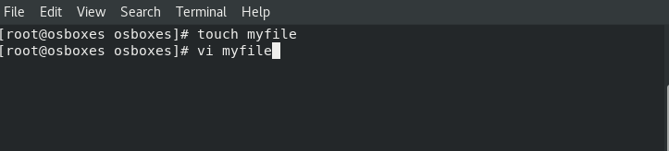

1. Edit all the required details and exit by pressing esc and then ‘:wq!’.

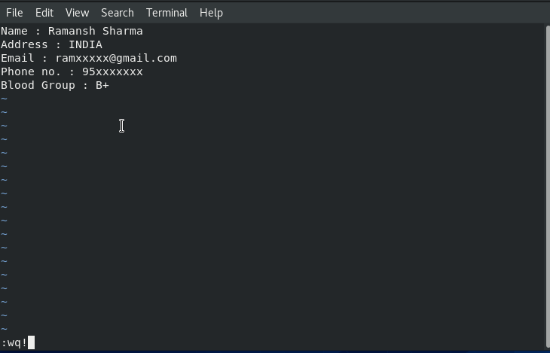

1. Then enter the command to view both name and blood at the same time from myfile.

